The Haunting Question of Intelligibility
Catherine C. Marshall
Microsoft Corporation
cathymar@microsoft.com

Almost fifteen years have gone by since Halasz (citing Trigg, Suchman, and Halasz’s work on collaboration in NoteCards [3]), brought up the issue of the mutual intelligibility of collaboratively constructed or shared information spaces [1]. “In the area of support for the social interactions involved in collaborative use of a shared network, the critical notion is mutual intelligibility,” wrote Halasz (p. 849).
I’d like to press the issue further: are the semi-formal or informal representations that are the basis for spatial hypertext intelligible to even their original author, given the passage of time (especially given that looking back on one’s work is, in essence, collaborating with oneself)? It’s easy to see that as the years roll by, we can forget why we put a document in a particular pile, or put a big purple check mark at the top of a page. But I would claim that the phenomenon of lost intelligibility can even take hold within the scope of a single sizeable task, given the ambiguous nature of the kinds of representations we expect in spatial hypertext.
What is the source of this doubt about the self-intelligibility of spatial hypertext?
Studying the artifacts people leave when they’re reading leads you to believe in their ultimate utility, and therefore in their intelligibility. What do I mean by artifacts? I’d include the way they organize their materials (piling them up, moving them from here to there, putting them into categories, etc.); the marks they make on documents (marginalia, highlights, and even bookmarks); the connections they make between things (e.g. links, adjacency); and other explicit and implicit records of interaction. These forms are so rich, and so expressive, that it seems that they must be meaningful to their authors. Furthermore, these are just the sorts of artifacts we’ve designed spatial hypertext systems to support.
But it seems that we have always had some doubts about the intelligibility of hypertext and spatial hypertext structures that have been constructed in service of interpretive activities (or even just to build shared information spaces). These doubts stem from studies of practice, not studies of artifacts in isolation. What seems self-evident at the outset – why an object has been put somewhere, why a mark has been made, why two nodes are connected – has seemed less so when people have had to account for the artifacts of their interpretive activity.
In pursuit of that doubt, and what it implies, I offer a few examples from field studies and other settings we have observed over the course of the last six years or so. Each example covers a different use situation and a different kind of artifact that one might see in a spatial hypertext – annotations, organizations, and bookmarks (references to the entirety of a node) – and each hints at a whole body of issues that beg to be explored.

Example 1: Annotation of a technical article.
The first example comes from a study we performed of a reading group [5]. Readers annotated technical articles in the course of preparing for a weekly reading group meeting. The annotations aided them in participating in or leading a face-to-face discussion of the article. The marks the readers made were naturally-occurring; we did not ask them to make any more (or any fewer) marks than they would normally make. They read both paper and electronic documents.
Less than a week after their regularly scheduled meeting we asked people about the marks they’d made on the articles. One participant admitted that a diagram he had drawn on the last page of the paper (see Figure 1) was now a mystery, but he was “sure it had some significance at the time.”

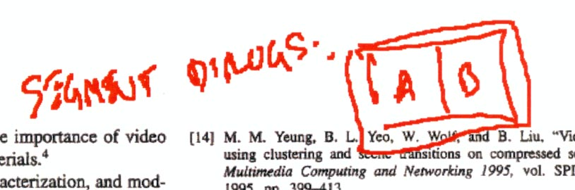
Figure 1. A diagram of now-uncertain meaning that a reader drew on a technical article.

I have confirmed this finding in several other field studies of annotation. By and large, people have trouble remembering the specific annotations they’ve made, why they have made them, and what they mean; this may stem in part from the unselfconscious nature of annotations, an unselfconsciousness that we believe is part and parcel of the success of spatial hypertext.
It seems, in fact, that annotations one makes for oneself might be less intelligible over time than collaborative annotations, since far less must be made explicit immediately, and since the personal annotations are unselfconscious while the collaborative annotations are necessarily authored for an audience.

Example 2: Organizing materials as a means of information triage

In our 1997 paper reporting the results of a study of how people perform the task of information triage – reading and sorting through a collection of relevant materials with a purpose in mind – we found that:

Rapid performance of tasks does not bode well for requesting extraneous work in documenting either process or product, or in building complex argument structures. Our subjects left only the briefest indications of how they had organized materials. [4]
Even the participants in the task realized that these brief indications of the meaning of a spatial hypertext were possibly insufficient to communicate its meaning, and certainly the informal encodings were by no means consistent by the end. If we examine what three different in the study said, we can pull out some common themes. The following quotes are from surveys of participants representing the three different study conditions, using paper, using spatial hypertext without hierarchical structures, and using spatial hypertext with hierarchy:

“[I would] read the info that I selected as critical more carefully and perhaps highlight some important text for my boss to help support my decision.” (From a study participant using paper)

“[I would do a] better job of re-organizing the documents: I spent my time coming up with a recommendation, not organizing the documents.” (From a study participant using spatial hypertext without hierarchical structures)

“I would organize each big collection into smaller collections and possibly change some of the names ... Also I would look a little more carefully at some of the articles as some might be misplaced.” (From a study participant using spatial hypertext with hierarchical structures)

The trade-off seems to be in making structure and interpretation more explicit and better articulated instead of focusing on the most immediate task (in this case, recommending some machine translation software to a multi-national corporation). And, of course, focusing on the task at hand wins every time.
People seem to know that it will help them down the line if they label the annotations that they make or the bookmarks that they save, but they seldom have the time to do so when they’re pressed by the demands of a particular task. The following quote is from a student in a very recent (unpublished) field study who is reconstructing why she has created a specific electronic annotation. She has the option of renaming it, but hasn’t:

“The key idea there is where he’s talking about kind versus degree. Um. And if I were being very scrupulous, I would have rewritten in my annotations index, I would have renamed it, “kind, degree” so I can remember this… Today I didn’t really have time.”

Example 3: Bookmarking a paper book

Bookmarking has become a ubiquitous activity because it is so readily supported by Web browsers. From examining typical lists of bookmarks (e.g. the one shown below in Figure 2, taken from an unpublished field study of office workers and their reading practices), we can see that it’s a perfect candidate for the organizing capabilities of spatial hypertext.
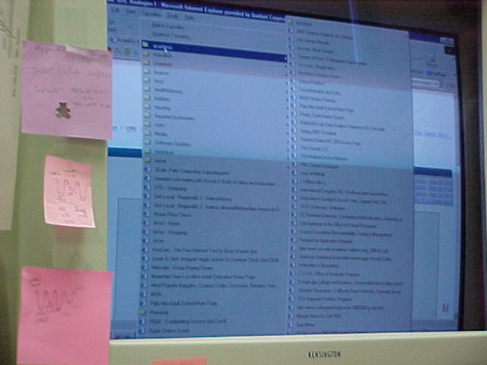
Figure 2. A typical list of bookmarks – this photo shows the contents of a single folder that is part of an extensive hierarchy.
Yet many of these bookmarks never rate repeated return visits; they are used in either a temporary way (for a particular task) and forgotten, or they represent only the vaguest of intentions – “I mean to get to this later” – a site that is never really visited again. This ambivalence is reflected in peoples’ accounts of their bookmarks, both on paper, and in their Web browsers. For example, when she was questioned about one of the novels being used as a text for a graduate level course, one student said:

“Yeah, I have a dog-ear in here… I can’t remember what that signified. But at the time when I folded the page over and probably at the appropriate instance after that, I remembered what that meant, what I was supposed to go back to.”
It seems that people mean to read and return to a great deal more material than they ever do. The passage of time diminishes their ability to recover their intentions. Certainly the desire to pursue references is a motivation for developing this kind of collection, yet again, accounts of this practice show that there’s a lot more gathering than there is pursuit. In our reading group study, we found that researchers (people who would be likely to follow up on references) said things like:

“Well, you know, it’s hard. Because during the reading, you don’t want to go to it. Right? Because it’s too distracting. Then, afterwards…” [5]

Reclaiming meaning
Is history sufficient to reclaim intelligibility and meaning? Certainly it is helpful to develop recording facilities within a spatial hypertext to capture events in its history, as Shipman et al. have done in VKB [7]. However, it is important to recognize that the key events that allow people to reconstruct meaning may well exist outside of the hypertext, and indeed, possibly even outside the computer. Or the events may be purely cognitive, and the actions in the spatial hypertext may be a fleeting record of the unselfconscious engagement that people have while they are working with different sorts of physical and digital materials. In any event, reclaiming meaning is difficult, neither automatic nor to be undertaken without strong motivating forces.
Does this mean that I think that the interpretation expressed through spatial hypertext is only valuable in a transient way? Emphatically, no. Even if the specific intelligibility associated with artifacts like annotations, organization, bookmarks, and other references is only accessible for a short period of time, the recording of such partial interpretation does at least three things:

- Spatial hypertext can create a lasting geography of the materials.
One thing that becomes obvious in conversations about personal annotations is that they’re useful beyond their immediate meaning. Even though readers don’t necessarily remember why they’ve made a mark, nor why they’ve “put that there”, these artifacts are a record of their previous engagement with the materials. In other words, spatial hypertext can create a lasting geography of information, even if the interpretive particulars have long since disappeared. One student using an e-book for her course work told me the following when she was trying to reconstruct her actions:

“So of this I’m starting to skim more. As it talks about things that are less relevant. I can’t remember – here’s another highlight, so I definitely read this far. Uh. I think I read to the end of the chapter. Yeah, there’s another highlight.”

Thus it was important to her that she’d read the text before, even if she didn’t remember the specific motivation for her marks. This notion of a persistent geography should transcend intelligibility. It is more a cue to memory – “I know I’ve seen this before” – than it is a specific interpretive act.
- Spatial hypertext can form the basis for meaning-reclaiming or meaning-making discussion.
What becomes increasingly evident from conversations about spatial hypertext-like constructs is that meaning can arise from discussion. Even if the original meaning is no longer accessible, there’s some utility to knowing that an object was interesting, belonged (or almost belonged) in a specific category, or that it was created at almost the same time as another object; in discussing the context, further fruitful collaborative interpretation can occur.
- Spatial hypertext can provide the starting point for capturing larger-scale phenomenon.
Recently much has been made of collective effects of individual behavior patterns – it’s why day-trading has not destabilized the stock market and why you should always believe the audience’s advice in Who Wants to be a Millionaire when you see a clear majority emerge (see James Surowiecki’s discussion of this effect in the New Yorker earlier this year). I have also observed similar patterns in annotations across individuals: the annotations single out important passages that are different than those set off by the authors or editors. [6]
Similarly, as we begin to store spatial hypertexts on mutually-accessible servers, we may begin to see the power of collective effects. Because spatial hypertexts potentially allow us to gather what we find relevant, interpret relative importance, form category structures, and record other properties of information, we may be able to use larger scale patterns to help us form more useful collections and more helpful metadata; this is somewhat analogous to the effective way Google uses link information to weight search results.
In other words, while we may find intelligibility to be elusive and recollection of intent to be faulty, we may also find that – as the Rolling Stones would have it – “if you try sometimes you just might find/You just might find/You get what you need”

References
- Halasz, F. G. (1988). Reflections on NoteCards: seven issues for the next generation of hypermedia systems. Communications of the ACM, 31(12), 836 – 852.
- Irish, P.M., Trigg, R.H. Supporting Collaboration in Hypermedia: Issues and Experiences. Journal of the American Society for Information Science, March, 1989.
- Trigg, R. H., Suchman, L., and Halasz, F.G. “Supporting Collaboration in NoteCards.” In Proceedings of CSCW ’86 (Austin, Texas, December 3-5, 1986), pp. 147-153.
- Marshall C. C. and Shipman, Frank M. III. (1997). Spatial Hypertext and the Practice of Information Triage. In Proceedings of Hypertext ’97 (pp. 124-133). New York: ACM Press.
- Marshall, C. C., Price, M. N., Golovchinsky, G., Schilit, B. N. "Introducing a digital library reading appliance into a reading group." In Proceedings of ACM Digital Libraries '99 (Berkeley, CA, August 11-14, 1999) pp. 77-84.
- Marshall, C. C. (1998). Toward an ecology of hypertext annotation. In Proceedings of Hypertext ‘98. New York: ACM Press.
- Shipman, F. M. III, Hsieh, H., Maloor, P., Moore, J.M. The Visual Knowledge Builder: A Second Generation Spatial Hypertext. to appear in Proceedings of Hypertext ’01. (Aarhus, Denmark, August 14-18, 2001).

