CSCE 221 Cover Page
Homework Assignment #5

First Name: Last Name: UIN:

Any assignment turned in without a fully completed coverpage will receive ZERO POINTS.
Please list all below all sources (people, books, webpages, etc) consulted regarding this assignment:

CSCE 221 Students Other People Printed Material Web Material (URL) Other
1. 1. 1. 1. 1.
2. 2. 2. 2. 2.
3. 3. 3. 3. 3.
4. 4. 4. 4. 4.
5. 5. 5. 5. 5.

Recall that University Regulations, Section 42, define scholastic dishonesty to include acquiring answers from any unauthorized source, working with another person when not specifically permitted, observing the work of other students during any exam, providing answers when not specifically authorized to do so, informing any person of the contents of an exam prior to the exam, and failing to credit sources used. Disciplinary actions range from grade penalties to expulsion. Please consult the Aggie Honor System Office for additional information regarding academic misconduct – it is your responsibility to understand what constitutes academic misconduct and to ensure that you do not commit it.

I certify that I have listed above all the sources that I consulted regarding this assignment, and that I have not received nor given any assistance that is contrary to the letter or the spirit of the collaboration guidelines for this assignment.

Today’s Date:

Printed Name (in lieu of a signature):
1. (25 points) Provide pseudocode for an in-place version of quick sort that uses a random pivot. Either provide a sequence that generates the worst case running time of O(n²) for this algorithm or explain why it is not possible.

2. (15 points) While exploring the ruins of an ancient civilization you find writings that give an algorithm for computing the median of n numbers in O(n) time. Of course, being a student in CSCE 221H, your first thought is that you could apply this algorithm to select a pivot for the deterministic version of quick sort. Given such an algorithm, what would be the worst case running time for your new version of quick sort assuming all elements are distinct? What would be the best case running time?

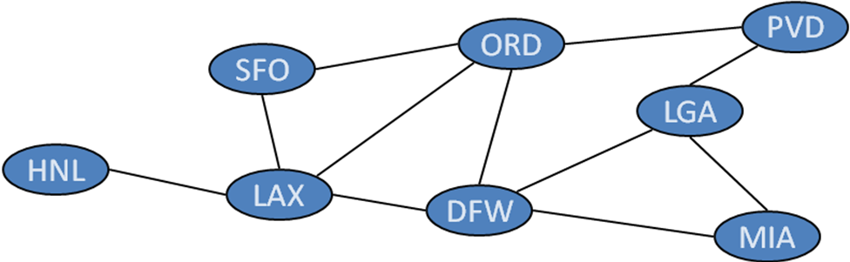
3. (60 points… 20 points for each sub-problem) Consider the graph above for the next few questions.
a. Draw an adjacency list representation of this graph.

b. Perform a DFS (depth first search) on the graph starting at DFW. Assume adjacent edges are processed in alphabetical order. List the vertices in the order they are visited and draw the spanning tree generated by this traversal.

c. Perform a BFS (breadth first search) on the graph starting at DFW. Assume adjacent edges are processed in alphabetical order. List the vertices in the order they are visited and draw the spanning tree generated by this traversal.

